

**BISure Accessories Company Ltd - Website User Manual**

Table of Contents

1. Introduction 2

1.1 Purpose 2

1.2 Target Audience 2

2. Website Navigation 3

2.1 Main Menu 3

2.2 Scrolling 3

3. Key Sections & Features 3

3.1 Homepage (Hero Section) 3

3.2 Welcome Note 3

3.3 Mission, Vision & Objectives 3

3.4 Products Carousel 4

3.5 Message to Customers 4

3.6 Contact Form 4

3.7 Footer 4

4. Managing Contact Form Submissions 4

5. Support & Contact 4

# 

# 1. Introduction

Welcome to the BISure Accessories Company Ltd website user manual. This guide provides detailed instructions on how to navigate, use, and manage the website effectively.

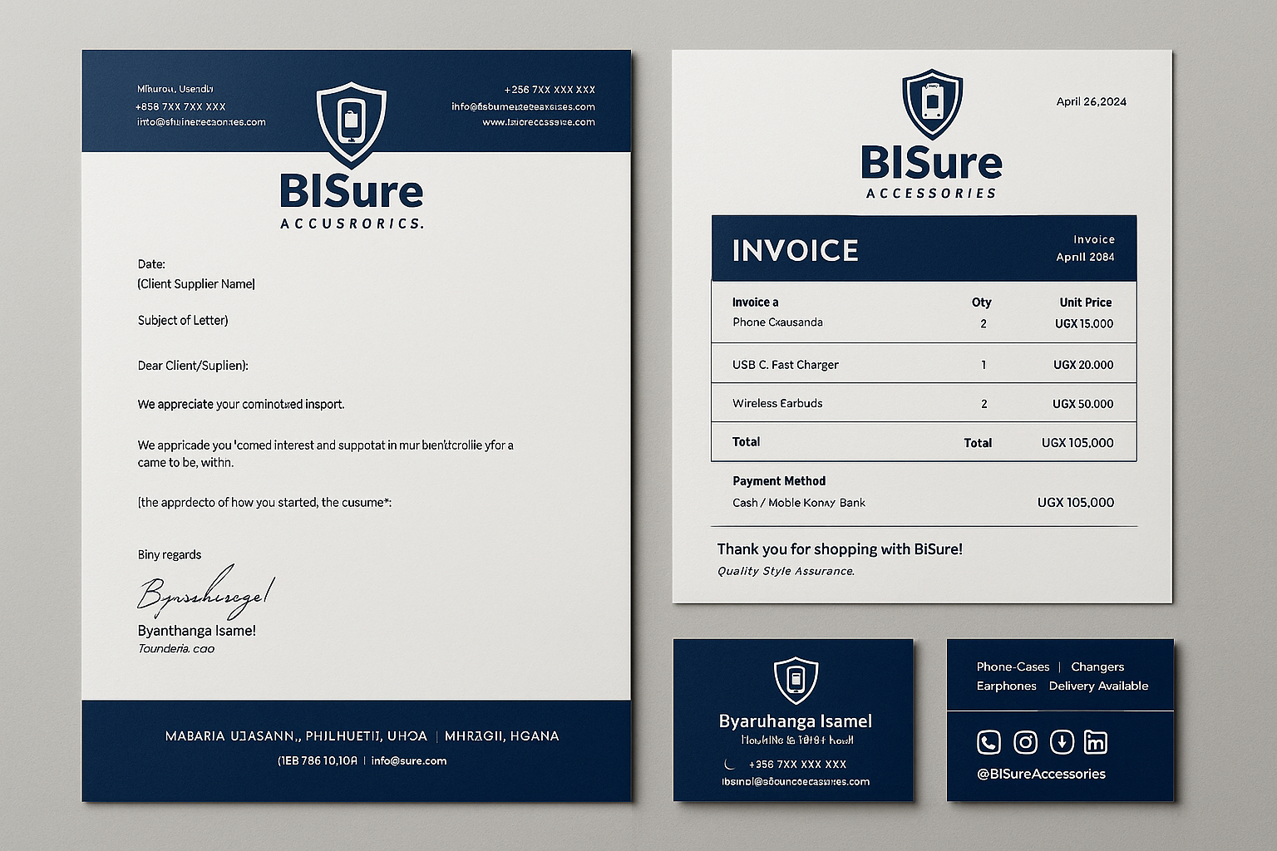

## 1.1 Purpose

The website serves as an online platform for:

* Showcasing tech products (phones, computers, accessories)
* Communicating company vision, mission, and objectives
* Allowing customers to contact the business
* Enhancing brand visibility

## 1.2 Target Audience

* Customers: Browse products, learn about the company, and submit inquiries.
* Administrators: Update content, manage products, and monitor messages.

# 2. Website Navigation

## 2.1 Main Menu

The navigation bar at the top includes:

* Home: Returns to the main page.
* About Us: Displays company vision, mission, and objectives.
* Products: Shows featured tech gadgets in a carousel.
* Contact: Links to the contact form and company details.

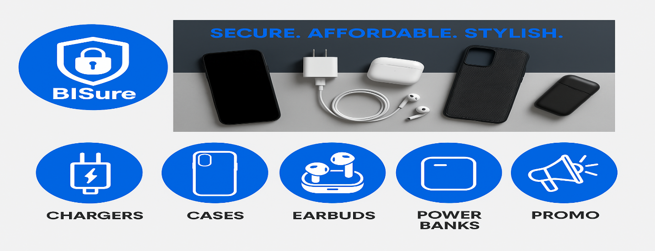

## 2.2 Scrolling

* The website supports smooth scrolling—clicking a menu item scrolls to the corresponding section.
* Alternatively, users can manually scroll through the page.

# 3. Key Sections & Features

## 3.1 Homepage (Hero Section)

* Displays a welcome message and call-to-action buttons:
* "Explore Products" → Links to the products section.
* "Contact Us" → Links to the contact form.

## 3.2 Welcome Note

* A personalized greeting to customers.
* Brief introduction to BISure Accessories.

## 3.3 Mission, Vision & Objectives

* Vision: Company’s long-term goal.
* Mission: How the company serves customers.
* Objectives: Key business targets.

## 3.4 Products Carousel

* Displays featured tech products.
* Navigation:
* Use arrow buttons (← →) to browse products.
* Dots indicator shows current slide position.

## 3.5 Message to Customers

* A dedicated section reinforcing customer trust and company values.

## 3.6 Contact Form

Allows customers to send inquiries.

Fields:

* Name (required)
* Email (required)
* Subject (required)
* Message (required)

Submission:

Click "Send Message" to submit.

A success notification appears upon submission.

## 3.7 Footer

* Quick Links: Easy access to key pages.
* Newsletter Subscription: Optional email signup.
* Social Media Links: Facebook, Twitter, Instagram, LinkedIn, WhatsApp.

# 4. Managing Contact Form Submissions

- Currently, form data is logged in the browser console (for testing).

For real email delivery:

* Use Formspree, EmailJS, or a PHP script.
* Replace the JavaScript function with an email service integration.

# 5. Support & Contact

For technical assistance, contact:

📧 Email: byaruhangaisamelk@gmail.com

**Conclusion**

This user manual provides all necessary details for customers and administrators to use the BISure Accessories website efficiently. For further customization, consult a web developer.

🚀 Happy Browsing! 🚀